**1) Introduction :**

* Our project is a Family Reunification Website..
* If anyone finds an unattended or suspicious child , one may click its photo and

upload in the website .

* The uploaded photo will match with the existing database of missing person and

validates whether the person is missing or not.

* Family of missing person can also upload their missing person image with their

Description.

**2) Background of Child Missing in India**

Child missing is a pressing issue in India, affecting the safety and well-being of children across the country. This report aims to provide an overview of the background factors contributing to child missing cases in India. By understanding these factors, it becomes possible to develop comprehensive strategies for prevention, intervention, and support. There are various factor affecting :

**2.1. Socioeconomic Factors:**

a. Poverty: Poverty is a significant factor leading to child missing cases in India. Families living in poverty may be compelled to send their children to work, making them vulnerable to abduction or trafficking.

b. Lack of Education: Limited access to education increases the risk of child missing. Illiterate or poorly educated parents may not understand the importance of child protection or be unaware of reporting mechanisms.

**2.2. Social and Cultural Factors:**

a. Gender Inequality: Gender inequality plays a role in child missing cases, with girls being particularly vulnerable. Discriminatory practices such as child marriage and female feticide contribute to the increased risk of girls going missing.

b. Social Norms and Traditional Beliefs: Certain social norms and beliefs perpetuate child missing. For example, children are sometimes considered as assets for economic gain, leading to their exploitation and trafficking.

**2.3. Criminal Activities and Trafficking:**

a. Organized Crime: Organized criminal networks engage in child trafficking for various purposes, including forced labor, sexual exploitation, and illegal adoption.

b. Human Trafficking: India serves as a source, transit, and destination country for human trafficking. Children are trafficked both domestically and internationally, further exacerbating the problem of child missing.

**2.4. Systemic Issues:**

a. Inadequate Law Enforcement: Challenges in law enforcement, including corruption, lack of resources, and poor coordination, hinder effective response and investigation of child missing cases.

b. Weak Data Management: Inconsistent and incomplete data collection and reporting systems make it difficult to accurately assess the scale and nature of child missing cases, hindering targeted interventions.

**2.5. Lack of Awareness and Support Systems:**

a. Limited Public Awareness: Lack of awareness about child protection issues, including child missing, hampers prevention efforts. Widespread awareness campaigns are necessary to educate communities and promote early reporting.

b. Insufficient Support Services: Inadequate support services, including counseling, rehabilitation, and reintegration programs, hinder the recovery and well-being of missing children upon their return.

**2.6. Government Initiatives and Collaborative Efforts:**

a. Legislative Framework: The Juvenile Justice (Care and Protection of Children) Act, 2015, and the Integrated Child Protection Scheme (ICPS) provide a legal framework for addressing child missing cases.

b. NGOs and Civil Society: Non-governmental organizations and civil society play a crucial role in supporting efforts to prevent child missing, provide assistance to affected families, and advocate for policy reforms.

**2.7. Conclusion:**

Child missing in India is a complex issue influenced by various socioeconomic, cultural, and systemic factors. Addressing this problem requires a multi-faceted approach involving legal reforms, increased law enforcement capacity, improved data management systems, public awareness campaigns, and comprehensive support services. Collaborative efforts between the government, NGOs, civil society, and communities are crucial to ensuring the safety and protection of children in India.

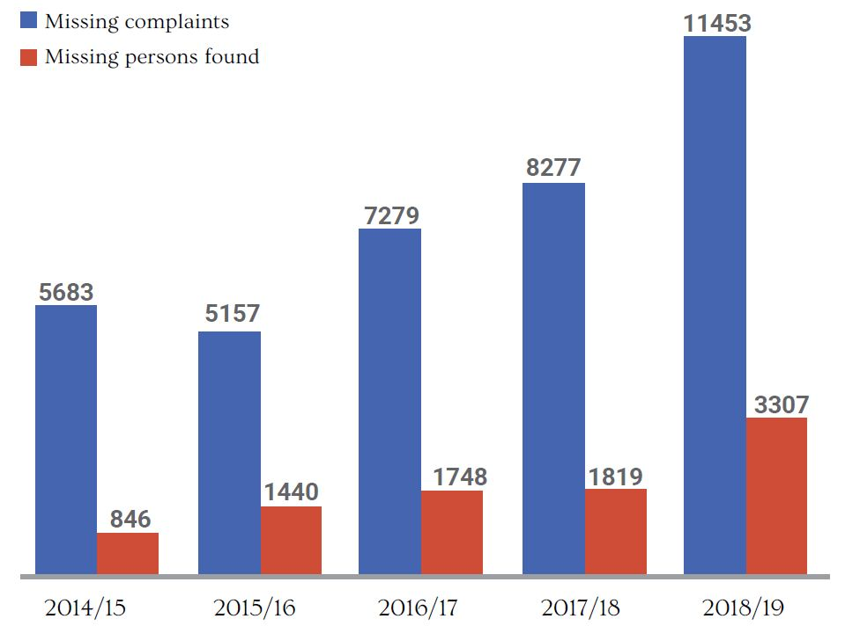

Majority of person were unfound

**3) Objective and Target (Gap Analysis)**

**3.1) OBJECTIVE:**

The objective of family reunification website project can be summarized as follows:

* **Reunite Missing Children**: The primary objective is to help reunite missing children with their families. By providing a platform where people can upload photos and information about missing or suspicious children, you aim to increase the chances of locating and identifying these children, leading to their safe return
* **Facilitate Communication**: Facilitate communication between users and relevant authorities or parents. By enabling messaging features, users can provide additional information or receive updates on the progress of the search efforts, enhancing collaboration and coordination.
* **Raise Awareness**: The project aims to raise awareness about missing children and encourage community involvement in their recovery. By making the website open-source and free to use, you are providing a valuable resource that citizens can utilize to identify if an unattended child is missing and take appropriate actions.
* **Utilize Face Recognition Technology**: By implementing a face recognition model, the project aims to leverage advanced technology to match uploaded photos with the existing database of missing children.
* **Enhance Reporting and Location Accuracy**: By incorporating features such as reporting exact locations through Google Maps, the project aims to enhance the precision and reliability of information provided by users.

**3.2) TARGET:**

The target of family reunification website project can be defined in terms of the beneficiaries and the goals aim to achieve.

* **Beneficiaries**: The primary target of project is the families of missing children. By providing a platform that increases the visibility and search efforts for missing person, we can aim to assist these families in reuniting with their loved ones.
* **Awareness and Engagement**: The project targets individuals and communities to raise awareness about the issue of missing children and encourage their active participation in the search and recovery efforts.
* **Efficiency and Accuracy**: By implementing advanced technologies such as face recognition models and location reporting through Google Maps, the aim to enhance the efficiency and accuracy of the search process. This can help authorities streamline their efforts, allocate resources effectively, and increase the chances of successful reunifications.
* **Collaboration and Support:** The project also targets organizations and stakeholders involved in child protection and missing persons cases. By establishing partnerships and collaborations with these entities.

Ultimately, the target of your project is to make a positive impact on the lives of missing children, their families, and the community by increasing the chances of finding and reuniting missing children while promoting awareness, engagement, efficiency, and collaboration among various stakeholders.

**4) Semester Milestone and Timeline**

* **Creation of website (1 week )**:- Our website will have two interface i.e parent and user . In the parent section , parent can upload their missing child picture and in the user section , user will be able to upload image of person to whom he/she finds suspicious.
* **Building Chatbot (3 days)**:- For interaction between parents and child to get more information and Google Maps API integration for location reporting.
* **Building AI Model (1 week)**:- Building AI model for face recognition of missing person.
* **Backend Development and Integration (1 week)**:- We will implement the necessary backend functionalities, such as user authentication, photo matching using face recognition technology.
* **Deployment and Launch (1 week)**:- Deploy the website on a reliable hosting platform or server. Perform final checks to ensure all components are functioning correctly in the live environment.

**5) Future Scope**

* In future we will focus on improving Facing Recognition Model Accuracy by

allowing it to compare distorted images clicked by user or if image is rotated , of

low resolution ,etc.

* We would offer real-time alerts that notify users when a new child has been reported

missing in their area.

* We will colab with NGOs and can provide information about volunteer opportunities

with organizations that help find missing children.

* Sharing success stories of children who have been found can give hope and encourage

people to get involved in the search for missing children.

* The website can provide contact information for law enforcement agencies or other

organizations that can assist in locating missing children.